"Antonio Lanzillo & Partners 10 years of projects"
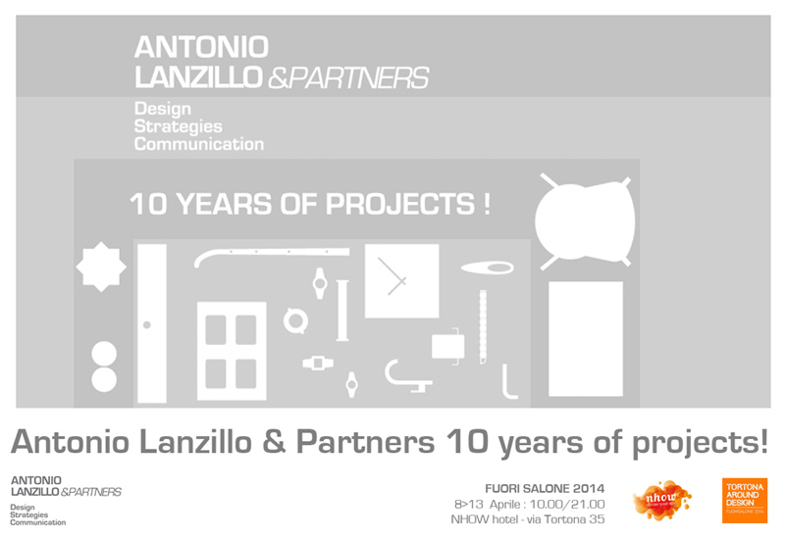

About ten years has passed from first project and Antonio Lanzillo & Partners Studio make a balance on their professional course and on various projects carried out in many industrial sectors. Dealing with product design, communication and art direction, they get in touch with important industrial companies in which they have been able to fully express their creativity.
With this retrospective on some significant projects, developed with significant Italian and foreign companies, they want to pay a tribute and a renewed appreciation to all companies and people with whom they collaborate looking to the future with confidence and optimism.
During Fuorisalone at the nhow hotel in Via Tortona, 35 the study has also selected three important Italian entities: Kunstdünger, Scatto Italiano and Marco Paghera that present themselves to the public.

Press kit online: https://dl.dropboxusercontent.com/u/17613885/Antonio%20Lanzillo%20%26%20Partners%20press%20kit.rar

Antonio Lanzillo & Partners is a multidisciplinary design’s studio where new strategies of product and communication are born! Milan studio founded in 2001. Claim Studio:“THINK BEFORE DESIGN”.
Antonio Lanzillo born in 1976 Italian Designer graduated at the Politecnico di Milano in industrial design. He began his business in 2001 and after various experiences in the field of manufacturing molds and of the molding of plastics he planned several chairs for the contract market; in 2002 was a finalist in the competition for the Turin 2006 Olympic brand.
He joined for 3 times from 2001 to 2003 at the Salone Satellite during the Salone del Mobile in Milan, in 2005 was awarded a plaque YOUNG & DESIGN by Rima and designed for Fontana Arte a collection of lamps called “Mobius”. In his C.V. there are also important experiences of international design such as Marc Sadler Design studio and Rodolfo Dordoni. In 2006 he designed several watches for Lorenz S.p.A; he designed the Verner chair for Colico Design and he became consultant for the Technogym group working for the Pure Strenght project; in 2008 he became consultant Research & Development Moribolo. In 2008 is becoming the official designer for Philip Watch of Morellato group. In 2009 he became a consultantof Rintal Scale and for LUBE group. From 2010 he was art director for VASART Urban Furniture company. In 2011 he designed the collection of bedrooms “SPORT” produced by FAER in 2011 becoming consultant for Webert planning a serie of Eisinger taps for Franke group. In 2012 he will introduce for Eurocucina two models of kitchens for two Italian companies: Lube anc Colombini. In the same year he designed the kitchen Pantone that has had huge success on the international media. In 2013 start the collaboration with Nextime and Kunstdünger leader in the market of communication and signposting product with the birth of Greenboarder an innovative e revolutionary roll up.
The project’s character is marked by a precise research of formal originality and functional innovation. His style is an original synthesis of research, observation, and intuition that translates in an industrial product.
The innate curiosity, respect to the past and the enthusuasm for the future are the engine of his design culture. His main customers are: Fontana Arte, Artec, Pantone Universe Asa Plastici, Lorenz Orologi, Technogym, Kunstdünger, CucineLube, AreaDeClic, Arrmet, Philip Watch, Morellato, Mobirolo, Vasart Urban Design , Webert, Faer, Nextime.

Antonio Lanzillo & Partners
Via Giovanni Antonio Amadeo, 57
20133 Milano- Italy
Phone +39 3498301770
Skype lanzillo.design.studio
info@antoniolanzillo.com
www.antoniolanzillo.com

